Business Question and Visualization Report
Date | 30 July 2026
Team ID | Archana kumari
Project Name | Food ordering behaviour and consumer trends
Maximum Marks | 5 Marks

Business Questions and Visualizations
Q1: Which city generates the highest total order value?
• Visualization: A Bar Chart displaying the total order value across different cities.
• Insight Provided: Identifies the cities contributing the highest revenue, helping businesses prioritize high-performing locations and plan marketing or expansion strategies.
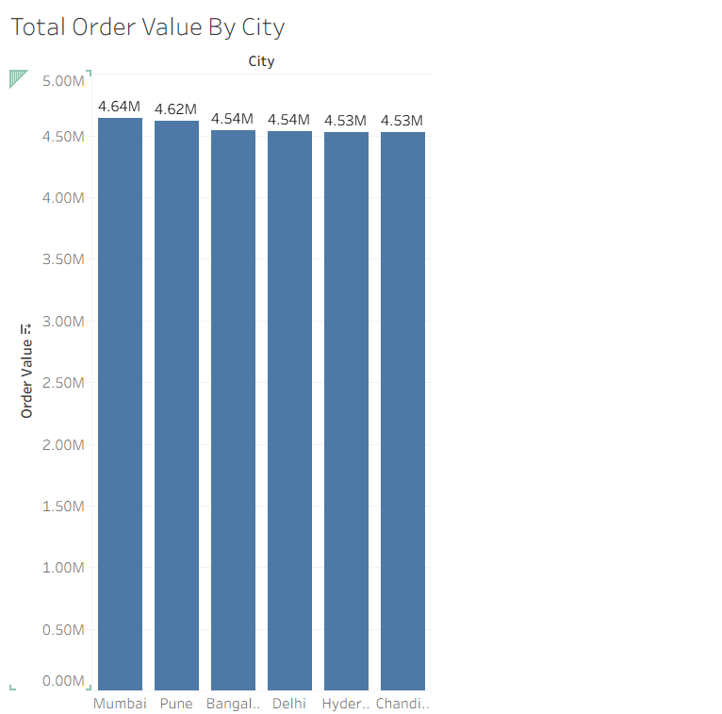
Q2: How does the average order value vary across different order times?
• Visualization: A Line Chart showing the average order value for Morning, Afternoon, Evening, and Night.
• Insight Provided: Reveals the time of day when customers place higher-value orders, enabling businesses to optimize pricing, promotions, and staffing.
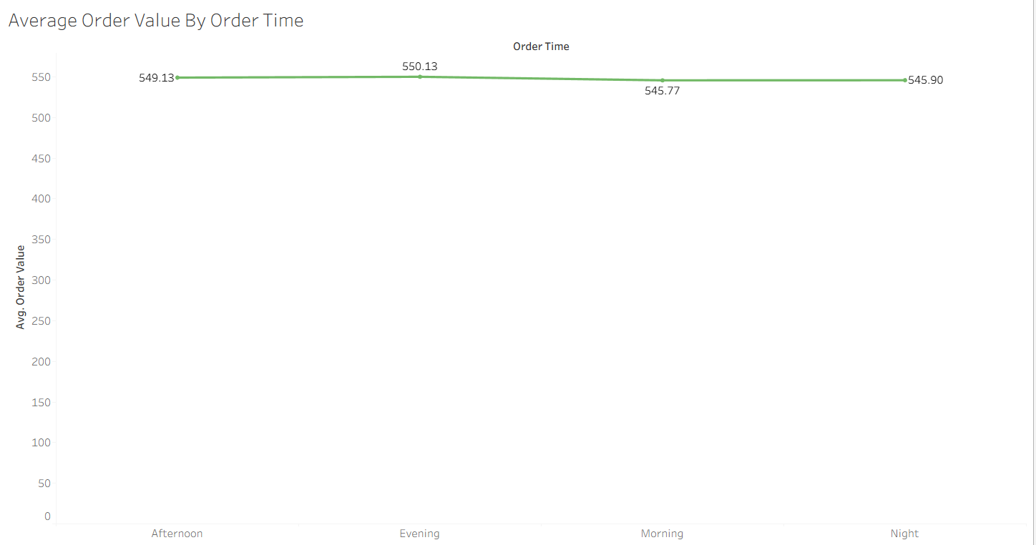
Q3: How is the total order value distributed across different order times?
• Visualization: An Area Chart illustrating the total order value during different order times.
• Insight Provided: Highlights peak ordering periods based on revenue generation, helping businesses allocate resources efficiently during high-demand hours.
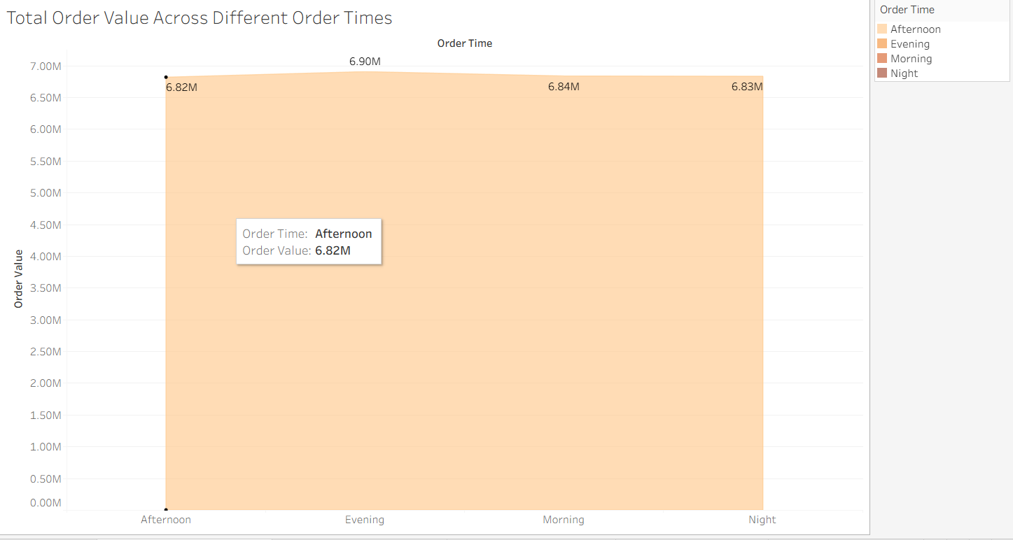
Q4: How are orders distributed across meal types and order times?
• Visualization: A Heat Map representing the distribution of orders by meal type and order time, with color intensity indicating order volume.
• Insight Provided: Identifies the most popular meal types at different times of the day, helping businesses improve menu planning and inventory management.
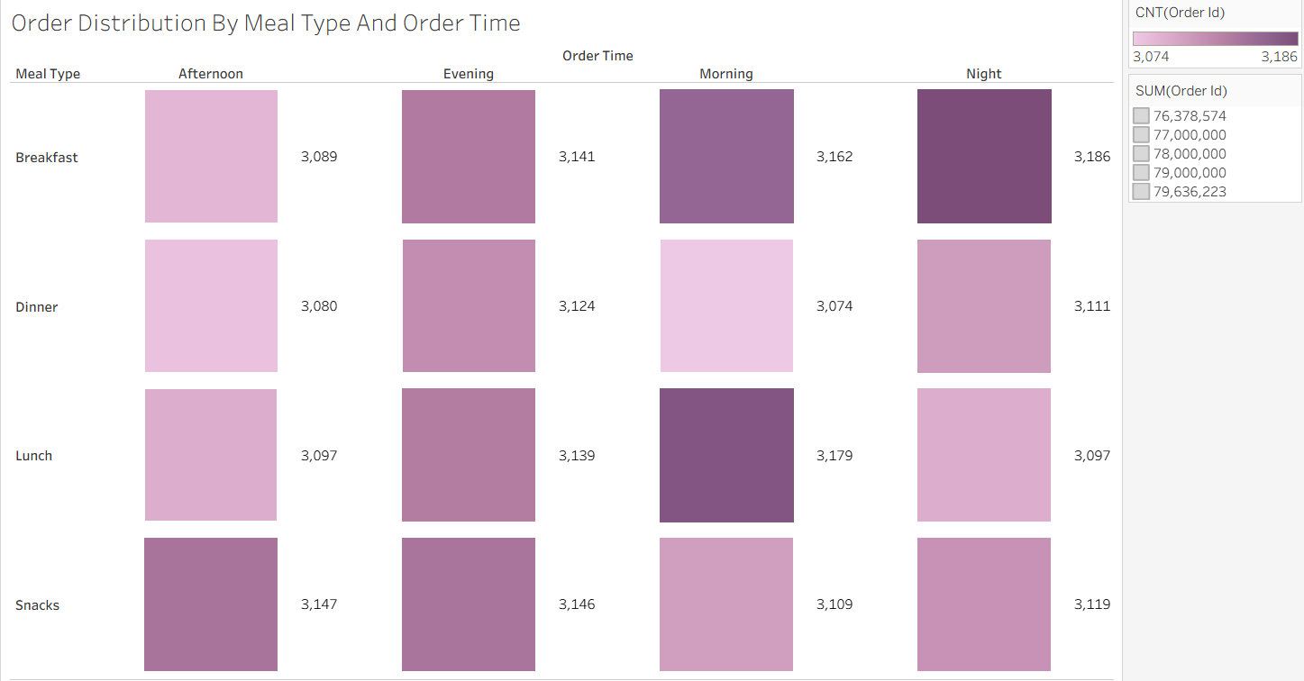
Q5: Which meal type contributes the highest total order value?
• Visualization: A Treemap displaying the total order value for each meal type, where the size of each rectangle represents revenue contribution.
• Insight Provided: Shows which meal types generate the highest revenue, enabling businesses to focus on their most profitable offerings.
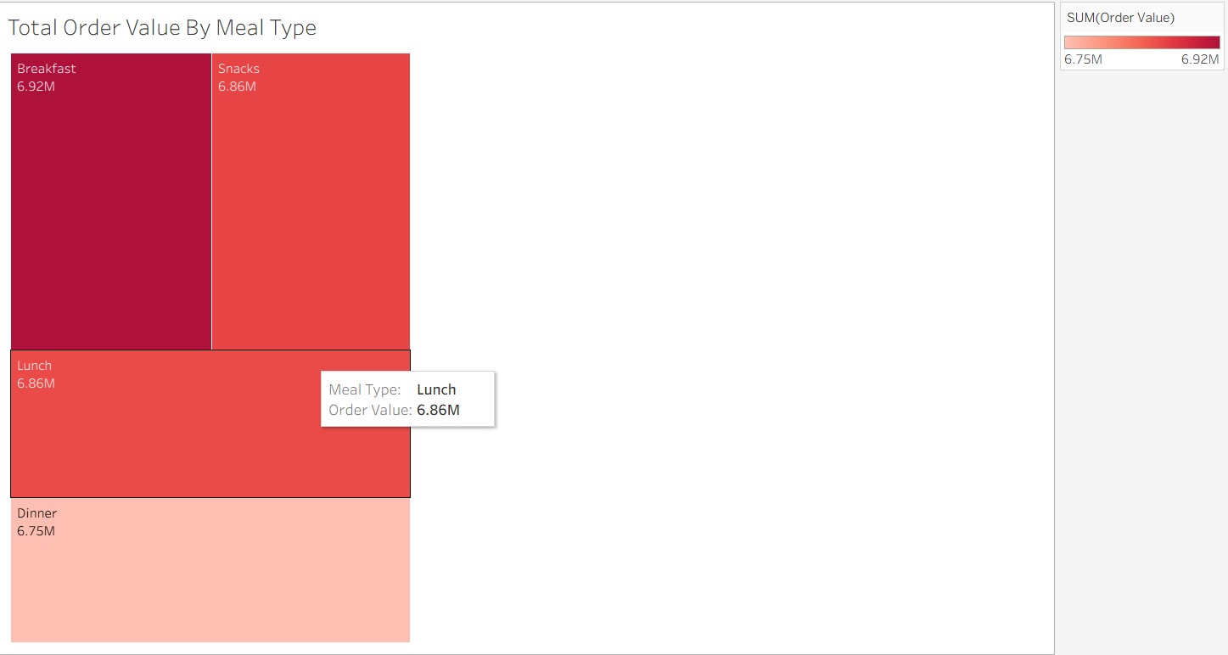
Q6: How are customer order values distributed across different value ranges?
• Visualization: A Histogram showing the frequency distribution of order values using bins.
• Insight Provided: Helps identify the most common order value ranges and understand customer spending patterns, supporting pricing and promotional decisions.
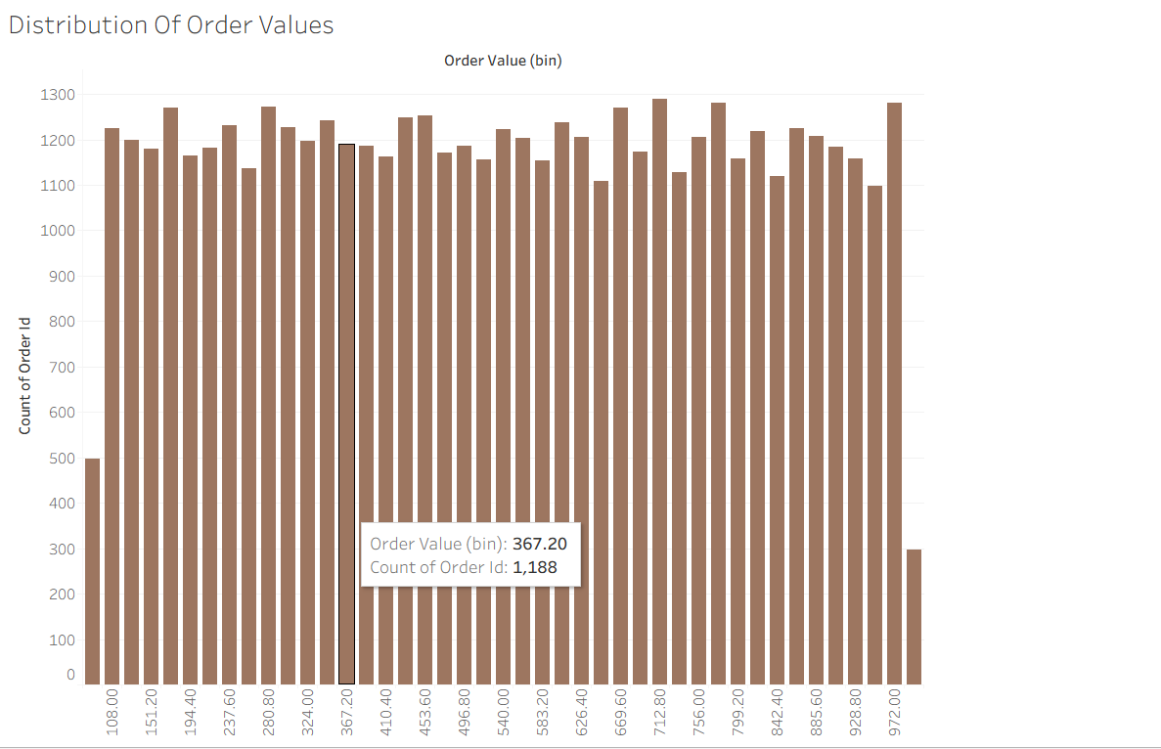
Q7: How does cuisine contribute to total order value across different cities?
• Visualization: A Stacked Bar Chart showing the total order value by city, with different colors representing various cuisines.
• Insight Provided: Compares cuisine-wise revenue contribution across cities, helping businesses understand regional customer preferences and optimize menu offerings.
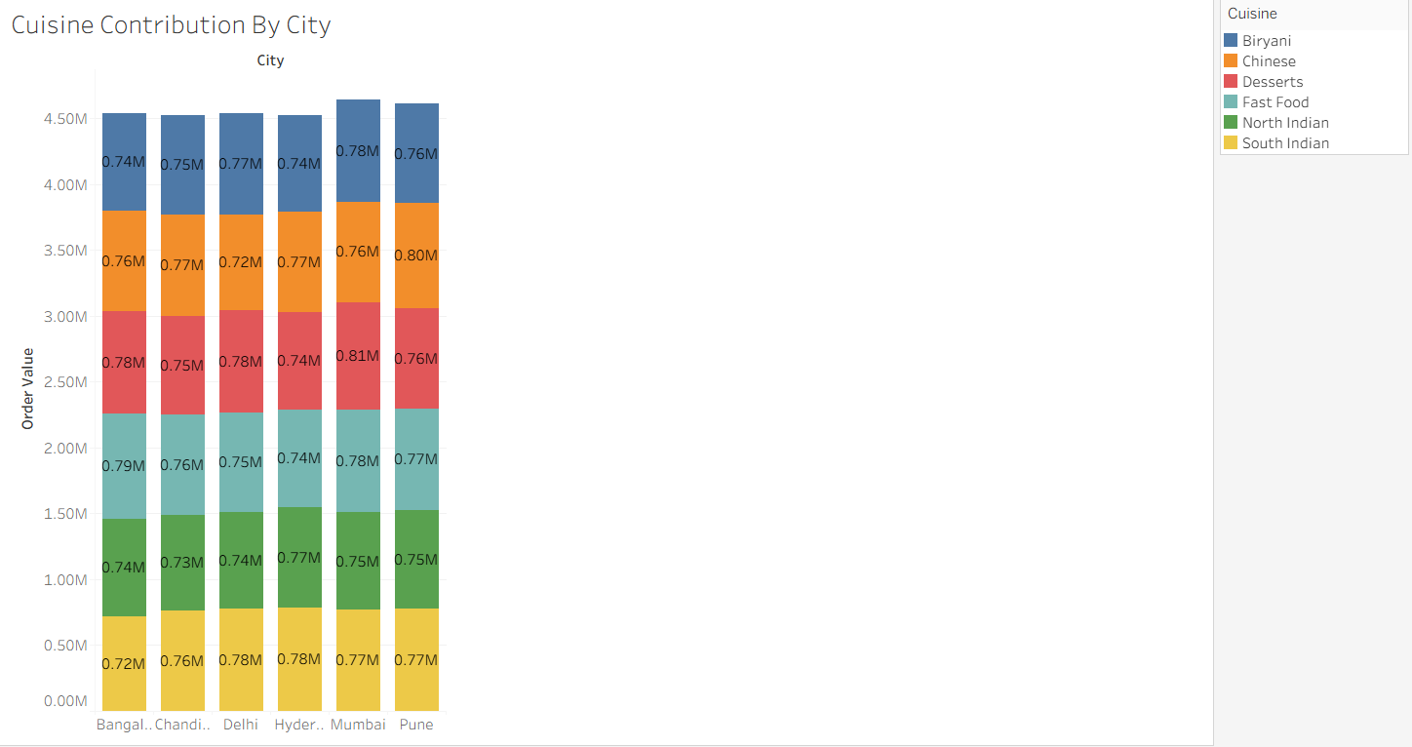
Q8: Which cuisine generates the highest total order value?
• Visualization: A Lollipop Chart displaying the total order value for each cuisine, where the line and circle represent the revenue generated by each cuisine.
• Insight Provided: Provides a clear comparison of cuisine performance, making it easy to identify the highest and lowest revenue-generating cuisines for strategic business decisions.
